Supplemental Budget request

COVID -19 Audit Requirements

$1,593,000 from Fund 483-1 to support mandatory increases in federal audit work and review new state financial system
Audits of COVID-19 Federal Funding
Prior to the COVID-19 pandemic, Washington’s annual federal spending was approximately $18 billion. In fiscal year 2020, federal expenditures increased to $26 billion after only three and a half months. We expect federal spending to increase to over $36.5 billion for fiscal years 2021 and 2022. We expect to require an additional 12,000 billable audit hours to complete the required single
audit for the next two years. These hours equate to $1,416,000 million in staff costs.
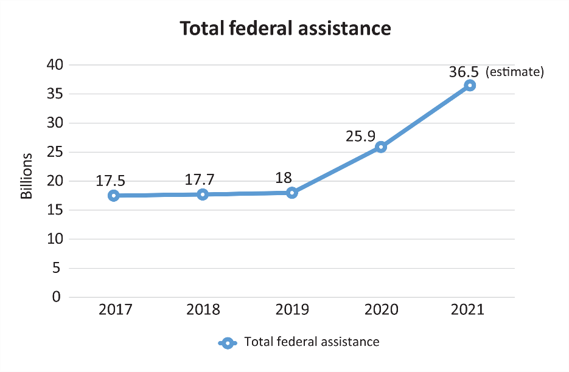
Washington has received new federal funding from:
- Coronavirus Aid, Relief and Economic Securities (CARES) Act
- Coronavirus Response and Relief Supplemental Appropriations Act
- American Rescue Plan Act (ARPA)
- Educational Stabilization Fund (ESF).
- Significant funding increases to existing federal programs, such as Medicaid and the Child Care Development Fund.
The federal government has established new and complex requirements for the pandemic related programs that recipients must follow.
This additional funding will ensure we meet our statutory single audit requirements and to report whether Washington used these funds properly and complied with applicable federal requirements. The funding will also ensure adequate resources to audit the federal Infrastructure and Jobs act, through which Washington is currently budgeted to receive an additional $8 billion.
As a share of the total federal dollars audited, our expected in FY2021 audit costs are a hundredth of one percent – 0.01 percent.

OneWashington- Examination of the State’s New Accounting System
In the current biennium, Washington will implement the first major phase of the OneWashington project. This phase of the project will replace the state’s financial reporting system (AFRS), built
on 1960’s-era technology, and will modernize the state’s functions for core financial records
and procurement.
Our IT Audit team will be reviewing the conversion process to verify data was correctly and completely transferred to the new system, as well as gain an understanding of the new system
and test key system controls. To improve operational oversight controls, we are planning to issue
a report about the conversion and implementation of the new system in the areas selected for
audit near the end of the 21-23 biennium. We estimate the cost of this additional work this this biennium to be $177,000.
Without this additional funding, SAO expects to cancel accountability audits for at least 20 state agencies, reduce audit frequencies at large agencies and conduct less work in high-risk areas, such as within the Health Care Authority. These steps will be necessary because audits of federal funding are mandatory, and would require a diversion of auditing resources from the above areas.
FOR FURTHER INFORMATION:
Office of the Washington State Auditor
Scott Nelson, Director of Legislative and Policy Affairs
564-999-0804, nelsons@sao.wa.gov

